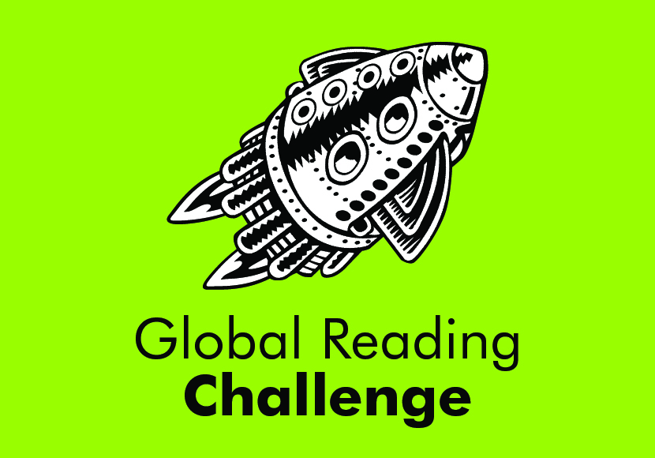

Wednesday, November 1, 2023

Dear Parents & Guardians of 4th & 5th Grade Students:

The Global Reading Challenge is upon us! We will once again, be participating in this event sponsored by the Seattle Public Library!

Global Reading Objectives:
- Promote a love of reading
- Introduce students to a wide variety of literature and multicultural reading materials
- Encourage reading for retention
- Encourage group activities and team work
- Provide a positive experience between students, librarians, teachers, parents, & books

The program is similar to the ‘Battle of the Books’, where teams read a selected number of books representing a wide variety of reading levels and answer questions based on specific factual and content information found within those books. Once we have a school winner, a Semi-Final Challenge will be held at the Central Branch of the Seattle Public Library. The winning branch teams will then compete in the Grand Challenge City Finals. If you would like more information about the Global Reading Challenge, visit the Seattle Public Library website: spl.org/GRC

North Beach will form approximately 7-8 teams of students – 7 members per team. Teams need to have a variety of reading abilities. Once teams are formed, students will choose a name for their team and begin forming their strategies for competing and embracing the joy of reading. For example, will all the team members read all the books, some of the books, or really get to know 2 books?

Although the actual dates for the In-School Challenge and Semi-Finals is yet to be determined, typically the In-School Challenge takes place in February and the Semi-Finals occurs in March. I will keep you posted once specific dates have been provided for our school.

Students who sign up for the Global Reading Challenge must commit to it and stick with it. They will have teammates that are depending on them. Certainly, regular classwork and homework come first, but this is not an average extra-curricular activity and only dedicated students who enjoy working with a team and who are truly
excited to participate, should apply. If you are ready to sign up, please fill out the attached permission slip and return to my mailbox located in front office or to the library by November 17, 2023. **(Please return permission slip only. The first 2 pages are for you to keep).

Teams will be posted outside the library entrance on Tuesday, January 2. Teams will be meeting twice a month on Wednesdays, beginning January 3rd. This time will allow teams to book talk, touch base with each other, and prepare for In-School Challenge together.

Finally, by signing up and participating in the Global Reading Challenge, you are giving permission for your child’s picture to be displayed on school bulletin board. If you do not want your child’s picture to be displayed, please contact me privately.

Sincerely,
Luci Bakker
Librarian
labakker@seattleschools.org
(206) 252.1527

